Intelligent Semi-automated Serious Educational Game Generation for the SimSYS Serious Educational Game Development Platform

TR xxxxx

author list

Acknowledgements

xxx.

Abstract

yyy.

Table of Contents

Acknowledgements ii
Abstract iii
Table of Contents iv
1. Introduction 6
2. Related Work 7
2.1 Different Instructional Approaches Adopted in Educational Games 7
2.1.1 Introduction 7
2.1.2 Comparison Criteria 7
2.1.3 Results and Discussion in Approaches 7
2.1.4 Summarized Results 9
2.2 Game Development in Education Automatic and Semiautomatic Methodologies 10
2.2.1 Introduction 10
2.2.2 Approaches to Accessibility in Games 11
2.2.3 Fully Automatic Adaptation of Interfaces - The case of 1492 12
2.2.4 Semiautomatic Adaptation - The case of "My first day at work" 13
2.2.5 Level of automatic and semi-automatic adaptation 15
2.2.6 Non-automatic adaptations and auditing tools 16
2.3 Automated Template-Based Metadata Extraction Architecture 17
2.3.1 Introduction 17
2.3.2 Metadata Extraction Approaches 18
2.3.3 Architecture and Implementation 18
2.3.4 Experimental Results 24
2.4 Automating e-Learning: The Higher Education Revolution 25
2.4.1 Introduction 25
2.4.2 5th Generation Distance Education: The Emerging e-University 26
2.4.3 Learner Relationship Management 26
2.4.4 Automating e-Learning 28
3. Your solution 1
3.1 Introduction 1
3.2 Detailed description 1
3.2.1 subheading 1
3.2.2 subheading 1
3.3 Tool Support 1
3.3.1 subheading 1
3.4 Validation results 1
3.4.1 subheading 1
3.4.2 subheading 1
3.5 Conclusions 1
4. Conclusions and Future Work 2
4.1 subheading 2
4.1.1 subheading 2
4.1.2 subheading 2
4.2 subheading 2
4.2.1 subheading 2
4.2.2 subheading 2
5. References 3
Appendix A. title here 5

Introduction

// a place to start is one paragraph for each of these:

Intro. to changing educational needs, how e-learning fits into that shift (include definition with reference for e-learning)
Intro. to serious educational games (include definition with reference of serious educational game)
Intro. to automation in serious education games (what other researchers have automated)
Intro. to the SimSYS Game Development Platform (overview, with references)
Focus in on the intelligent semi-automated game generation component
Why is this research needed?
Brief overview of the component, research methodology (including validation), and results
Structure of this report

Related Work

In this section, first we discuss about different approach in educational games. In next part Game Development in Education Automatic and Semiautomatic Methodologies will be explained. In third part Automation for non e-learning systems like Template-Based systems will challenged. Finally in the last part of this section, automation in e-learning system will be discussed.

Different Instructional Approaches Adopted in Educational Games
In this section we conduct a preliminary investigation attempting to examine how educational games implement instructional strategies to promote the players’ deeper understanding. According to the criteria proposed to this study, five studies were selected from the Social sciences Citation Index (SSCI) database for this review. Through the analysis, the instructional approaches reviewed consisted of prediction-observation-explanation (POE), self-explanation, and interactivity. In addition to description of each instructional strategy, limitations and possible remediation were discussed and proposed for future research.

Introduction
There is a growing trend on using educational games to promote and improve academic learning. Numerous studies point out that advantages of educational games consist of engaging students in learning activities, supporting learning by doing, and practicing problem-solving skills. Even with these merits, it is still challenging for games designers to develop games that enhance deep learning. According to the researcher, many educational games tend to support the practice of factual information. That is, the player are inclined to keep performing certain of actions (e. g. clicking on a button) until the score improve. Reflection becomes the last thing they do, which may impair generation of sophisticated understanding. Thus, researchers and educators encourage integration of instructional methods or pedagogy into the design of educational games. But, little attempt has been made. The purpose of this study was to review research studies of educational games so as to investigate how the instructional strategies were implemented in the games for enhancing the players’ deeper understanding. This study also analyzed the limitations indicated in each study and proposed possible suggestions for future research.

Comparison Criteria
This is a preliminary investigation attempting to examine how educational games implement instructional strategies to promote the players deeper understanding.
The researchers searched the relevant papers by using the Social Science Citation Index (SSCI) database for this review. The selection criteria include: 1) implementation of educational games(s); 2) integrating instructional strategies or pedagogy; 3) offering measurement of students’ learning outcomes. Five studies were found according to the criteria. The instructional strategies in each study were first introduced and then analyzed through the framework mainly including the targeted population, pedagogy, measurement of learning outcomes, and possible limitations.

Results and Discussion in Approaches

The prediction-observation-explanation (POE)
A prediction-observation-explanation model is a potential approach to increase learners’ conceptual change. According to the researchers, the model consists of three main tracks: predicting the outcome of an event or situation and justifying the prediction, observing the demonstration, and finally explaining the possible discrepancies or congruencies between their prediction and observation. In the study, the POE model was integrated into the game design to support the third-graders’s acquisition of light and shadow concepts. In each stage of the game (four stages in the game), the players have to answer a question as well as justify the option selected before playing. During the observing process, the player has one minute to observe the shadow of the different objects (e. g. trees, chairs, or statues) through directing an avatar to walk around in the game context. This enables the player to understand what the accurate shadows of the objects look like. When the time is u, the player should identify five objects, randomly selected from ten, whose shadows were modified to be inaccurate forms according to the objective in each stage. When finishing each stage, a quiz pops out and then the player needs to answer a question as well as justify the option selected. The results show that those who played the game integrating the POE model outperformed those who did not in terms of the scores of the immediate test.

Self-explanation
Self-explanation is a method that prompts students to generate their own explanation orally, in writing, or through replying to a multiple-choice question. Its intention is to engage the learners in reflection during the learning process as well as to support the linkage between the newly learned materials and prior knowledge. The researchers designed a circuit game incorporating a self-explanation feature. The goal of the game requires each player to solve ten circuit-related problems within a specific time. Scores are added or deducted whenever the players provide an accurate or inaccurate response to the problem. The players of a self-explanation group need to select a reason from a list before responding to the problem. The results show that those who played the self-explanation game outperformed those who played the game without self-explanation design. Regarding the type of self-explanation, those who selected a reason from multiple options gained higher scores than those who typed a reason themselves.

Collaboration
A number of studies have indicated that students can benefit from cooperating with peers in a learning activity. Collaboration refers to a situation that two or more students work together on constructing knowledge and solving problems. In a game environment, collaboration enables players to guess and discuss about game moves, strategies, or arguments. In the study investigating the effects of cooperative learning on playing a computer games, the results show that the engagement of the students who worked in pairs did not decrease. Furthermore, they outperformed those who played individually in terms of the posttest scores.

Problem-Based Gaming (PBG)
Problem-Based Learning (PBL) is an ideal way to engage learners in cognitive processes so that they can build knowledge or develop skills to solve problems effectively. The researcher proposed a Problem-Based Gaming (PBG) model that emphasizes the integration of authentic learning tasks, experiential learning, and collaboration into a game context. After the game-playing, players can easily transfer the learned knowledge or skills into practice since the targeted content had been anchored into the problem-solving situations games in which they needed to run a manufacturing company with a falling profitability. To compete with some groups, they should manage the material flows, read market reports, and come up strategies against their competitors. The results display that the students showed a positives attitude toward the PBG game. They felt themselves involved in learning by doing as well as generating reflective thinking during the game.

Guidance, reflection, and interactivity
A pedagogical agent (e.g. a talking head) refers to either static or animated anthropomorphic interfaces implemented in a multimedia context to serve different instructional purposes, such as offering feedback, prompting questions, or supporting interactions. The researchers conducted three experiments to investigate how students’ deep learning was enhanced in an agent-based multimedia game that integrates instructional methods: guidance (the agent explains why an answer is accurate), reflection (learners are prompted to explain why an answer is accurate), and interactivity (learners are asked to respond to a problem instead of receiving an answer from the agent). The results show that ether guidance or reflection was able to support students’ science learning in a game context. In addition, reflection also fostered retention and far transfer only when the students were encouraged to reflect on the correct solutions provided by the agent (interactivity). That is, if asked to reflect on their own solutions, the students might not benefit from playing the game.

Summarized Results
In summary, this study intended to increase the understanding of researched and educators about integration of instructional methods into educational games. Its ultimate goal is to help them to decide what method(s) to be used to develop effective games that fulfill educational purposes. The analysis revealed that all the five studies identified a positive impact of educational games on improving the students’ learning outcomes. Table 1 displays the summarized results of the five studies. As shown, most games conducted a knowledge test to assess the players’ learning outcomes. A helpful suggestion, according to the researchers, is to offer the players another gameplay after the test so that researchers can examine whether the design can engage them in the game and to improve their learning gains. Educational researchers have identified social interaction as a potential to promote players’ engagement and motivation, especially when implemented in a game environment supporting group discussion. Although two studies adopted a cooperation strategy in their game, those in groups merely used one computer. Thus, it is interesting as well as challenging for future studies to examine whether having each group member use one computer may impair learning outcomes. And what strategies should be taken into consideration during developing the games? Of note, all the games in the five studies did not take adaption feature into the design, even though adaptive instructional systems have been proposed more than ten years.

Table 1: The summarized results of the studies reviewed
Author(s) | Pedagogy | Limitation or Suggestion
Hsu et al. (in press) | Predict-observe-explain (POE) | - The design of narration might impose cognitive load on the preschoolers.  - The participants’ prior knowledge was not examined before playing the game.
Johnson & Mayer (2010) | Self-explanation | - The game context is too simple to match the complexity of computer games.  - It is suggested to provide feedback or scaffolding to help the player generate self-explanation.
Kiili (2007) | Problem-based gaming | - Rigorous efforts on developing a game fulfilling the complexity.  - Should support multiplayer connection.  - Cognitive overload for those without sufficient domain knowledge.
Moreno & Mayer (2005) | Guidance, reflection & interactivity | The study was limited to one type of interactivity, guidance and reflection. Future studies can design various types of strategies and examine the effects on improving learning outcomes.
Van Der Meij et al. (in press) | Cooperation | - The game might be unable to Support Sufficient depth of the dialogues.  - It is suggested to allow the players to another the gameplay after being tested to see if their learning outcomes are promoted.  - Test feedback can be designed by having the players debrief about the essential game features.

Game Development in Education Automatic and Semiautomatic Methodologies

Serious games are increasingly being used in education to support the development of skills that future professionals and citizens require. However, the inclusion of games in the curricula can threaten the universal right to education for students with disabilities if they are not designed to be accessible. In this paper we discuss the need for tools that assist educators and educational content providers in producing games that are equally accessible for all. The goal is to minimize the cost and effort needed for introducing accessibility in serious games. We discuss to what extent the process of making a serious game accessible can be automated and supported by software tools that minimize human intervention. We conclude that there is a set of common accessibility barriers, especially those related to interaction and physical disabilities, that can be addressed systematically in a high proportion and therefore could be dealt with by software. Other problems, especially those more close to structure, story-board and design, still need direct intervention from the game authors, but could be facilitated with appropriate methodologies and auditing tools.

Introduction
Education is a universal right, and this adds an imperative to consider accessibility as a high priority requirement whenever new technologies are brought into the educational process. Otherwise we may be threatening the equality of opportunities for all students. This should be the case of educational games (a.k.a. serious games), which are rapidly gaining acceptance, and will probably become a relevant educational tool for enthusiastic teachers in the next few years . But actual level of accessibility in videogames (both commercial and educational) is still low compared to other kind of technologies and digital static contents like the web .
One of the main arguments to explain the few attention that accessibility receives in games is that it means an extra burden for the developers and an increase factor of the investments. Firstly, design complexity increases. Games are intricate, heterogeneous and highly interactive applications that provide unique experiences depending on who is playing and what title is being played. Designing an engaging, appealing and meaningful game for a wide number of users is an art that requires loads of expertise and creativity. When designers have also to cope with the special needs of users with disabilities the difficulty of the job increases substantially. And secondly, developers are faced with extra implementation challenges. Dealing with accessibility usually requires integrating (or even developing) complex and expensive technologies, such as text-to-speech or voice recognition. And it may even require producing special hardware (e.g. adapted game controllers).
All these overheads may be affordable for large entertainment game development projects, and even then most entertainment games tend to ignore accessibility concerns. However, educational games do not typically have large budgets, with many initiatives being led by enthusiastic educators and organizations with little resources. To avoid leaving accessibility concerns out of these projects, making accessible game-based educational content should be as seamless and cost-effective as possible. To accomplish this goal, we advocate for making the process as automated and straightforward as possible, limiting human intervention when possible in order to alleviate the cost overhead. To achieve the objective, it would be necessary to integrate accessibility tools and technologies in educational games development software, thus facilitating the implementation of accessibility features. This would facilitate design by providing game authors (i.e. educators) with reusable components and interfaces that are ready to use, resulting in significant savings.
This paper aims to answer the question of to what extent the introduction of accessibility in educational games can be automated. We build on our previous experiences developing accessibility solutions for educational games that we have tried to integrate in the eAdventure game platform.

Approaches to Accessibility in Games
Traditionally, accessibility in games has been addressed individually in most of the cases, either adapting a specific title to meet the needs of a particular user profile, or developing games for a specific community of users with disabilities. Audio games, for example, are designed for users with a visual disability. How-ever, other approaches have adopted a more general and holistic perspective, proposing frameworks and methodologies that consider the needs of different profiles of users that could also be applied to different types of games.
For example, in the authors propose Unified User Interface Design, a methodology for designing universally accessible games where game tasks are devised with-out considering a specific modality or interaction device. In further design phases, alternative interaction methods are designed for each task depending on the needs of the target audience. Therefore the game design is extensible, facilitating the subsequent inclusion of accessibility features to cater for the needs of other users.
The eAdventure Educational Game Platform
eAdventure (formerly <e-Adventure>) is a game authoring platform especially oriented to education. Although eAdventure’s capabilities support the creation of a variety of 2D games, it was originally focused on point-and-click adventure games. This decision was driven by the consideration that these are the most appropriate genres for education because of their strong narrative underpinnings and pre-dominance of reflection over action. From an accessibility perspective, this genre does not pose barriers such as time pressure or fast-paced action, although a variety of barriers related to modality remains (they are highly visual, require moving a mouse for identifying objects, etc.).
There are two components in eAdventure: a game editor used to create the games and a game engine, used to run them. The typical workflow is to create and test the games with the editor, and then use editor's exportation features to produce a distributable package bundling all the assets that the game engine needs to process the games, which are a set of XML documents that describe the game and art resources (images, sounds, videos, etc.). The game editor includes education-oriented features and tries to simplify the game creation process as much as possible.
The game universe in eAdventure games is defined by composing elements of different types: characters, items, active areas, and the game scenarios (a.k.a. scenes), which are composed by a 2D background image and a set of interactive elements.

Experiences Developing Accessible Interfaces with eAdventure
We have used eAdventure to explore the automatic generation of accessible interfaces for two games that we present in this section as case studies. Upon the eAdventure source code, we built components that adapted the user interface depending on a given user profile. In this section we will elaborate on the level of automation achieved in each case. For each case, we have evaluated the usability from the end user’s perspective, by asking different users to interact with each type of resulting accessible interface. Further technical details on the implementation of these interfaces can be found on previous publications.
The official eAdventure distribution complies out-of-the-box with a certain level of accessibility for users with hearing disabilities, as all the information provided by audio can also be displayed with text. It is also accessible for users with a cognitive disability as it integrates an adaptation engine that allows game authors to tailor the game experience to each user capabilities (e.g. alternative contents or puzzles or skipping complex parts). For that reason, our work has focused more on improving accessibility for users with visual and motor disabilities.

Fully Automatic Adaptation of Interfaces - The case of 1492
In a previous work we have described a prototype built upon eAdventure v1.0 that supported alternative modalities through a combination of input and output modules. Two user profiles were considered: blind users and users with a motor disability. Among the wide variety of levels of visual impairments, we characterized the blind user profile as users that needed the aid of screen reading software to use a computer. We considered users with a motor disability as those needed of using voice recognition software to interact with a computer due to reduced or lack of mobility. Both user profiles encounter barriers when interacting with point-and-click applications as they are not able to use the mouse.
The game author was only allowed to enable or disable the modules during the exportation process. All the adaptation to the user profile was performed automatically by analyzing the game description XML files and art resources (see Fig. 1).
The results were two new modalities which had common inner workings. The interaction was performed through short commands formulated in natural language (e.g. "grab the notebook" or "talk to the character"). An interpreter received the commands, executed them if they were correct, and provided feedback about the results using the appropriate channel for the active user profile (auditory for the blind user through a built-in text-to-speech engine, text for the user with a motor disability). Blind users introduced the commands using the keyboard, while users with a motor disability used speech.

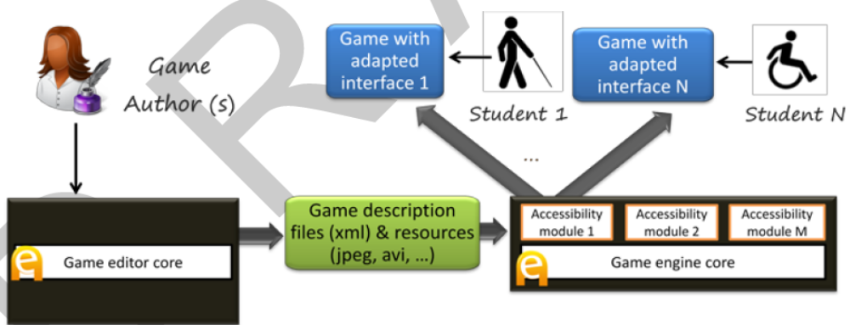
Fig 1. Basic accessibility architecture. Accessibility was provided by specific input/output modules integrated with the engine, which are activated when the game was exported.
Command processing was directed by a regular grammar combined with a fixed list of synonyms for relevant verbs (actions) and nouns (interactive elements). The regular grammar was automatically generated from the description of the game, taking the actions defined for the interactive elements available in each game scenario. During game play, the number of actions and interactive elements available in eAdventure games is susceptible to change at any time as they depend on the value of a number of variables that vary dynamically according to the rules the game author specifies (this is the mechanism that eAdventure provides to define the game structure and flow). To deal with this issue the grammar was rebuilt each time an internal variable changed and also each time the scenario was reloaded.
This approach was applied to the 1492 game (available from the eAdventure web-site). It was evaluated by two users, one of each profile. Users were able to interact with and complete the accessible version of the game in the experiment (around 20 minutes of game play), but the system presented several usability flaws. The most important was that the user's vocabulary did not always match the system's vocabulary, defined by a list of synonyms that included at least 4 equivalent words for each keyword. As a result, command recognition accuracy was low, having little chances of succeeding if the game had taken longer to complete. Natural language processing techniques, combined with a well-defined ontology containing a wider vocabulary may overcome this type of issues. Such ontology could effectively cover most of the vocabulary related to actions, as these are common for most eAdventure games (e.g. grab, use, talk, examine, etc.). However, the nouns used for the game items cannot be anticipated as these are user-defined, requiring the game author to provide additional synonyms. Other usability problems found may be solved by improving the implementation of the system (e.g. delays in the auditory feedback generated).

Semiautomatic Adaptation - The case of "My first day at work"
Building upon the experience of the 1492 game, we conducted another experiment which resulted in the game "My first day at work", developed in collaboration with Technosite, a company of the ONCE (National Organization for the Blind in Spain) group. We refined the process to address the limitations found (see Fig. 2) by improving flexibility of the accessibility features that now could be configured with the game editor.
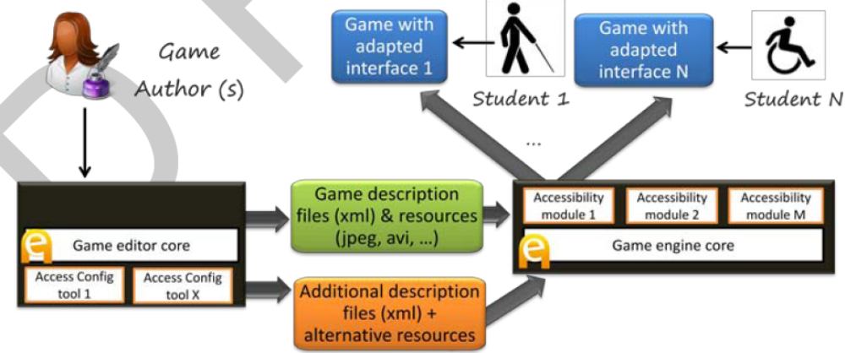 Fig. 2. Improved architecture and workflow. The accessibility features are now configurable from the editor to match different user profiles. The editor also produces automatically additional description files and resources.
In addition to the blind and motor disability profiles, a new user profile was considered: users with low vision. Colleagues from Technosite identified the adaptations this profile needed, which included screen and text magnification and use of a high contrast color scheme. Low vision users were expected to have problems to inspect the game scenes and find interactive elements as for them shapes and images blur with the background of the scene or with other elements.
We tried to keep the human work needed to accommodate the needs of these users to a minimum. The approach followed was to develop a low vision mode in the game engine. We started by developing an alternative rendering mode that improved the contrast of the interactive elements over the background of the game scenarios. This kind of technique has been applied to improve the accessibility of other games in the past, although focus has been placed on a single title instead of trying to build a generic and reusable system. This kind of adaptation introduced the novelty of modifying the rendering pipeline (i.e. how the game is painted), in contrast to blind users and users with a motor disability that required adapting the modality. The game engine automatically applied a light green filter to the interactive elements which in-creased their brightness and a dark purple filter to decrease the brightness of other areas, facilitating the identification of those interactive elements. Font sizes and colors used for cursors, buttons and menus were also automatically adapted.
However further adaptations were needed. Through early prototypes we found out that some scenes could not be adapted by automatically applying a filter, like those using images with text embedded. In these cases, authors should produce alternative graphic resources and include them in the game manually.
Although "My first day at work" was focused on meeting the needs of the three be-spoken profiles (blind, motor disability and low vision), we also tried to make it accessible to users with cognitive disabilities (e.g. Down and Asperger syndromes). We wanted to explore the kind of adaptations these users require, who usually experience difficulties to understand complex language, memorize large pieces of information or present attention deficit disorders.
Dealing with these problems is much more complicated and there is little room for automation. The eAdventure adaptation engine was used to provide alternative paths in the game with different levels of difficulty, or alternative versions of text intensive components such as conversations.
The game was evaluated by 10 users with a disability (3 blind users, 4 with low vision and 3 with reduced mobility). Apart from minor usability problems that could be solved by researchers during the experience, all users were able to complete the game (around 60 minutes of game play).

Level of automatic and semi-automatic adaptation
In the case studies presented the kind of adaptations that were required to meet users' needs varied across profiles. These adaptations affected diverse aspects of the game and were achieved with different levels of automation.
Table 1 shows a summary of the adaptations performed. Adaptations related to the modality, how the user interacts with the game or perceives the game feedback are prone to be automated (e.g. interfaces for blind users and users with reduced mobility). This does not mean that solutions are straightforward, but that current state-of-the-art in technologies like text-to-speech or voice recognition allows building inter-faces that can be used by a high number of users. Once these interfaces have been built, they can be reused across different games with little extra work.
Table 1. Summary of adaptations performed for each profile. Table reflects what aspect of the game were affected and the level of automation achieved.
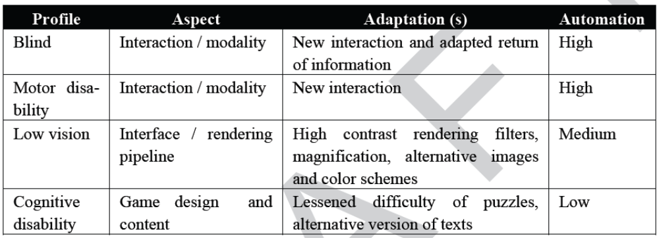

Other types of disability require adapting how the game is rendered (e.g. users with low vision). The process can be automated to some extent, as the rendering pipeline in game engines can be configured to apply transformations over specific elements, like applying filters, using alternative color schemes (for example to deal with color blindness) enlarging images or providing a magnifier. However, there is a point where alternative versions of art resources may be needed, having a greater impact on the cost of the game. In the case of the game "My First day at work", it was necessary to produce 647 art resources in first instance, including images, animations for characters, videos and sounds. To make it accessible for users with low vision it was needed to produce alternative versions of 53 art resources, an increase of 7,57%. Although this value is not very high it could increase exponentially if more profiles were considered (e.g. users with color blindness), so it is important to keep the number of manually crafted alternative resources as low as possible.

Non-automatic adaptations and auditing tools
Other accessibility profiles (e.g. those related to cognitive disabilities) may not be subject to automatic adaptation and therefore are harder to address. The adaptations they require are related to the design of the game, which is difficult to analyze and modify without requiring the intervention of the game author. Some AI techniques could be explored to solve some of the problems, like using automatic text analysis to simplify the language used if the user has a cognitive disability, but it is unlikely to achieve similar levels of automation to those previously described in section 3.
In these cases other approaches could be followed. Game authors could be provided with tools to perform accessibility auditing over the games, following the guide-lines of the W3C ATAG recommendation. These tools would work as accessibility evaluation tools for the web, searching the game structure for potential accessibility barriers (e.g. complex language, too many interactions available in a game scene, use of time pressure, etc.).

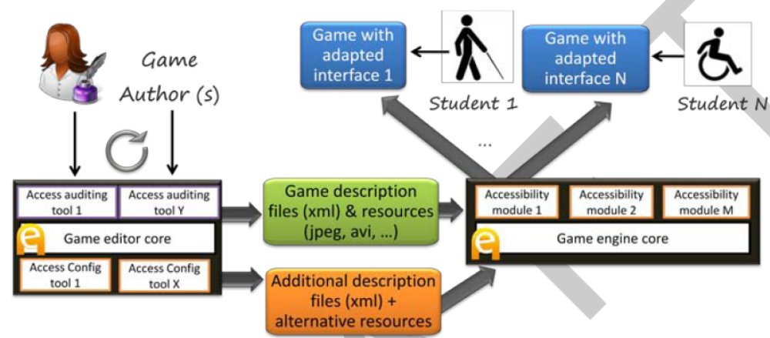
Fig. 3. Final architecture and workflow. Auditing and feedback tools are added, forming an iterative process of accessibility improvement.
An additional benefit of inspection and auditing tools is that they are educational, as they can recommend solutions to the game author and give further details about why problems encountered may endanger access for users with disabilities. The results of the auditing process could be presented in a human readable report, but could also be displayed in their context while the game runs to maximize the educational value. However, developing auditing tools is only feasible if the structure of the game is explicitly defined, as it is in eAdventure and most game authoring software, but not in game engines or frameworks where the game structure emerges or is implicitly defined. The final diagram of editing and running accessible games would look like the one Fig.3 shows.

Automated Template-Based Metadata Extraction Architecture

Introduction
This section describes our efforts to develop a toolset and process for automated metadata extraction from large, diverse, and evolving document collections. A number of federal agencies, universities, laboratories, and companies are placing their collections online and making them searchable via metadata fields such as author, title, and publishing organization. Manually creating metadata for a large collection is an extremely time-consuming task, but is
difficult to automate, particularly for collections consisting of documents with diverse layout and structure. Our automated process enables many more documents to be available online than would otherwise have been possible due to time and cost constraints. We describe our architecture and implementation and illustrate the effectiveness of the tool-set by providing experimental results on two major collections DTIC (Defense Technical Information Center) and
NASA (National Aeronautics and Space Administration).
A number of federal agencies, universities, laboratories, and companies are placing their collections online and making them searchable via metadata fields such as author, title, and publishing organization. To enable this, every document in the collection must be catalogued using the metadata fields. A typical cataloguing process requires a human to view the document on the screen and identify the required metadata fields such as title, author, and publishing organization, and to enter these values in some online searchable database. Manually creating metadata for a large collection is an extremely time-consuming task.
According to Chrystal, it would take about 60 employee-years to create metadata for 1 million documents. These enormous costs for manual metadata creation suggest a need for automated metadata extraction tools.
The Library of Congress Cataloging Directorate recognized this problem and sponsored a study, Automatic Metadata Generation Applications (AMeGA), to identify challenges in automatic metadata creation.
Though time consuming, the task of identifying metadata fields by visually looking at the document is easy for a human. The visual cues in the formatting of the document along with accumulated knowledge and intelligence make it easy for a human to identify various metadata fields. Writing a computer program to automate this task is a research challenge. Researchers in the past have shown that it is possible to write programs to extract metadata automatically for a homogeneous collection (a collection consisting of documents with a common layout and structure).
Unfortunately a number of federal organizations such as DTIC, GPO , and NASA manage heterogeneous collections consisting of documents with diverse layout and structure, where these programs do not work well. Furthermore, even with the best possible automated procedures, numerous sources of error exist, including some that cannot be controlled, such as scanned documents with text obscured by smudges, signatures, or stamps.
A commercially viable process for metadata extraction must remain robust in the presence of these external sources of error as well as in the face of the uncertainty that accompanies any attempts to automate “intelligent” behavior. How to reach the desired accuracy and robustness for a large and evolving diverse collection consisting of documents with different layout and structure is still a major research issue. We have developed and demonstrated a novel process for extracting metadata. Among the innovations is a two-part process that directly addresses the problem of coping with large heterogeneous collections by breaking the extraction problem into smaller, manageable pieces:
• A new document is classified, assigning it to a group of documents of similar layout. The goal is to group together documents whose title or other metadata-containing pages would appear similar when viewed (by humans) from several feet away.
• Associated with each class of document layouts is a template, a scripted description of how to associate blocks of text in the layout with metadata fields. For example, a template might state that the text set in the largest type font in the top-half of the first page is, in that layout, the document title.
We have tested our process and software against the DTIC collection which contains more than one million documents and adds tens of thousands of new documents each year. The documents are diverse, including scientific articles, slides from presentations, PhD theses, (entire) conference proceedings, promotional brochures, public laws, and acts of Congress. Contributions to DTIC come from a wide variety of organizations, each with their own in-house standards for layout and format, so, even among documents of similar kind, the layouts vary widely. Our tests resulted in an overall accuracy of 83% for documents with defined templates.

Metadata Extraction Approaches
Existing automated metadata extraction approaches can be divided into two main categories: learning systems and rule-based systems.
Learning techniques including SVM and HMM have been employed with promising results but to relatively homogeneous document sets. The investigators' own experiments with these techniques suggest a significant decline in effectiveness as the heterogeneity of the collection increases. We believe that exposure of these learning systems to heterogeneous collections tends to dilute the internal probabilities that control their internal transitions. Evolution (changing characteristics over time, such as acquiring a new source of documents in an unfamiliar format) poses a difficulty for these techniques as well, as they necessarily exhibit significant inertia resisting changes to the internally acquired “knowledge” until a significant number of examples of the new characteristics have been encountered. Rule-based systems use programmed instructions to specify how to extract the information from targeted documents. With sufficiently powerful rule languages, such Techniques are, almost by definition, capable of extracting quality metadata.
Heterogeneity, however, can result in complex rule sets whose creation and testing can be very time-consuming . Analogies to typical software complexity metrics suggest that complexity will grow much more than linearly in the number of rules, in which case even a well-trained team of rule-writers will be hard-pressed to cope with changes in an evolving heterogeneous collection and maintain a conflict-free rule set.
Our own approach can be seen as a variant of the rule-based approach, but we finesse the complexity induced by heterogeneity and evolution by first classifying documents by layout, then providing a template for each layout, so that templates are independent of one another and individually simple.

Architecture and Implementation
Overview of Architecture
Our template-based metadata extraction system is composed of commercial and public domain software in addition to components developed by our team. Figure 1 shows the complete process. Documents are input into the system in the form of PDF files, which may contain either text PDF or scanned images. Some documents may contain a Report Document Page (RDP), one of several standardized forms that is inserted into the document when the document is added to the collection. For the DTIC collection, more than 50% of the documents contain RDPs offering more than 20 metadata fields.

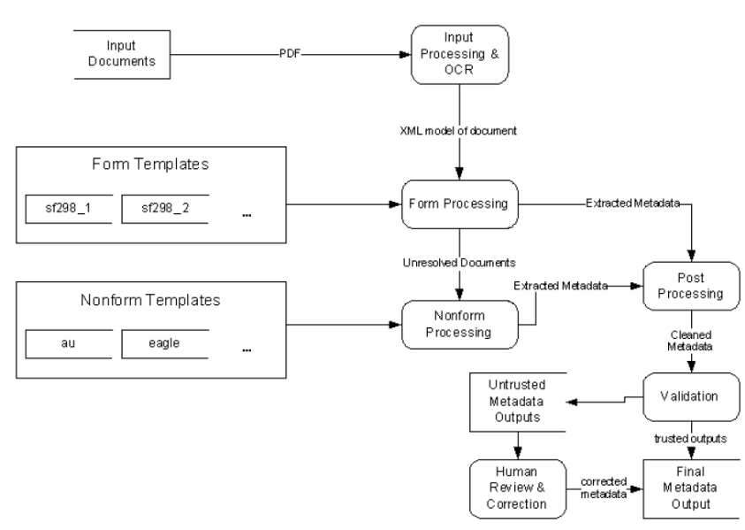
Fig. 1. Metadata Extraction Flow Diagram

The documents enter the input processing system where they are truncated, processed by an Optical Character Recognition (OCR) program and converted to a standardized XML format. The first extraction step is to search for and recognize any RDP forms present. Any documents without recognized forms enter the non-form extraction process. The non-form extraction process generates a candidate extraction solution from the templates available. After extraction, the metadata from both form and non-form processing enter the output processor. The output processor is comprised of two components: a post-processing module and a validation module. The postprocessing module handles cleanup and normalization of the metadata.
The final automated step of the process is the validation module which, using an array of deterministic and statistical tests, determines the acceptability of the extracted metadata.
Any document that fails to meet the validation criteria is flagged for human review and correction.

Implementation
Input Processing. The source documents come into our system as PDF format files. These documents range from several pages to hundreds of pages in length. Our research into the collection has shown that the metadata we are interested in can typically be found in the first or last five pages of a document.
Based on this observation, we use the program pdftk to split the first and last five pages out of the document and into a new PDF document. This truncated PDF document is fed into a commercial optical character recognition (OCR) for conversion into an XML format. We have selected ScanSoft’s OmniPage Pro as the OCR engine since it supports batch processing of PDF files with very good results. OmniPage saves the recognized file into a proprietary XML format which contains page layout as well as the recognized text.
The initial prototype of our extraction engine was based on the proprietary XML format used by OmniPage Pro version 14. However, by the time of the deployment of the initial prototype, the site was using OmniPage Pro version 15, which uses a different proprietary format that changed every XML tag except for the “word” tag and added dozens of new tags. Our form-based extraction engine is tightly coupled to the schema of the incoming XML documents, so supporting this new version of the OmniPage schema would require major recoding of the extraction engine, with the end result being another tight coupling to another proprietary schema. To forestall any future conflicts with schema changes, we decided to develop our own schema to decouple our project from proprietary schemas.
Independent Document Model (IDM). We based our new Independent Document Model (IDM) on the OmniPage 14 schema we already supported with our project. This step helped to minimize the re-coding cost for the extraction engine. The main structural elements are pages, regions, paragraphs, lines and words. The geometric boundaries of each of the structural elements are included as attributes. Style information such as font face, font size and font style, is recorded at the line and word levels.
Alignment and line spacing are recorded at paragraph elements. Tables are composed of a sequence of cells that represent a virtual row-column table with each cell encoded with the upper-left coordinate and the row and column spans of the cell. IDM documents are created by means of XSL 2.0 stylesheets. A different stylesheet is used for each type of source document. We have created stylesheets to support creation of IDM documents from either OmniPage 14 or 15 source documents. Similarly, additional OCR programs can be supported in the future by creation of XSL stylesheets to make the transformation.

Form Processing. Our experience with the DTIC collection has shown that about 50% of the documents contain an RDP form. The regular layout present in an RDP form makes it an attractive target for a template-based extraction process. In order to take advantage of the geometric relationships between fields in a form, we created an alternate version of our template language and extraction engine. The metadata fields are specified by a matching string and a set of rules indicating a positional relationship to one or more other fields (e.g., Figure 2). The number and layout of the fields for each different form constitute a unique signature for that form class. If a template describing form A is applied to a document containing form B, the resultant
metadata returned will contain few if any fields. We have leveraged this property in the design of our extraction process.
Input processing finishes with IDM based documents exiting the input processor and entering the form processor. The processor is populated with a template developed for each version of RDP form found in the collection. We have found six different RDP forms within 9825 documents in the DTIC collection. The form processor runs the extraction process against the document using each of the templates and then selects the template, which returns the best results. If the form processor fails to match any template the document moves into the non-form extraction process described below. The extracted metadata is sent into the output processor.

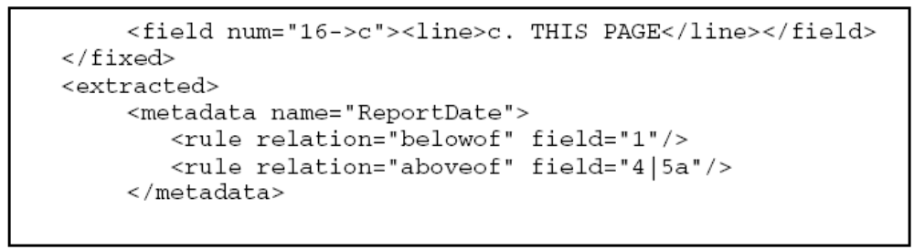
Fig. 2. Form-based template fragment. The (line) elements in the (field) elements define string matching criteria. The (rule) elements defined for each (metadata) element defines the geometric placement.

Non-form Processing. As shown in Figure 1, documents without an RDP form enter the non-form processor. The documents are first transformed from IDM into another XML format called CleanML, which encodes the paragraphs and lines and their corresponding features (font size, style and alignment) into an XML structure. This simplified structure allows the extraction engine to repeatedly iterate over the content to apply the rules.
Template Construction. The non-form extraction engine also uses rule-based template extraction to locate and extract metadata. Each template contains a set of rules designed to extract metadata from a single class of similar documents.
Figure 3 shows a template example. Each desired metadata item is described by a rule set designating the beginning and the end of the metadata. The rules are limited by features detectable at the line level resolution. We hope to address this deficiency in future versions. The first step in constructing a template is to identify a set of documents which share a structural or visual similarity. Once a class is selected, the template author determines the set of rules for each metadata tag by identifying the appropriate function to select the beginning and the end of the tag.
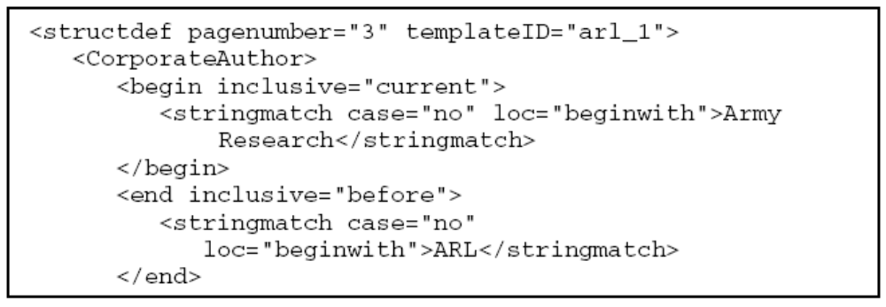
Fig. 3. Non-form Template fragment
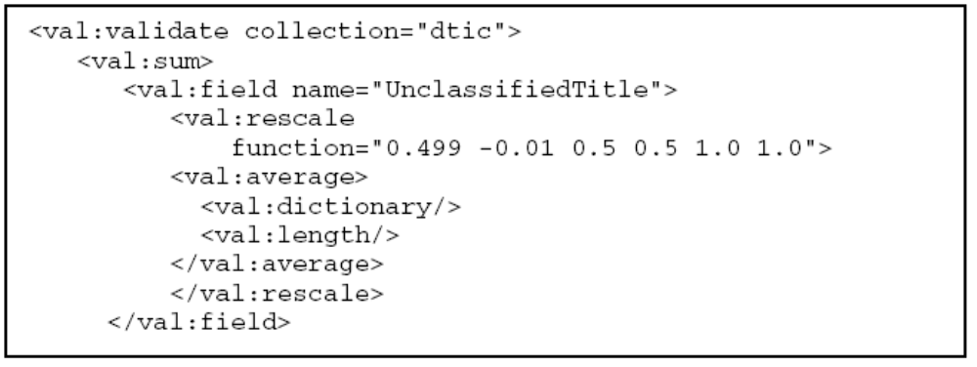 Fig. 4. Validation script fragment for DTIC collection. Each metadata field such as “UnclassifiedTitle” and “PersonalAuthor” is assigned a function for validation.

Non-form Classification. For purposes of our discussion we define a class as a group of documents from which the metadata can be extracted using the same template. The members of a class can be selected based on structural or visual similarity. The original design of our system used several different layout classification schemes in order to separate the incoming documents into the appropriate class for extraction. As described later, we also created a validation system to flag suspicious data extracted by a template.
We found that by applying every available template to a document, we could use the validator as a post hoc classification system for selecting the proper template. This post hoc classification system is configured by creating a “validation script” (e.g., Figure 4), which defines a set of rules to be used for calculating a confidence value for individual fields as well as an overall confidence calculation.
Figure 5 is an example of the validator output for the “alr_2” template. Table 1 shows the validation values for five of the eleven templates applied by the extraction system for the same
file. (The other six templates did not produce any output for the file.) The best result, alr_2, differs from the next best, alr_1, by the extraction of an additional personal author. This is precisely the behavior and level of discrimination we desire in a classifier.

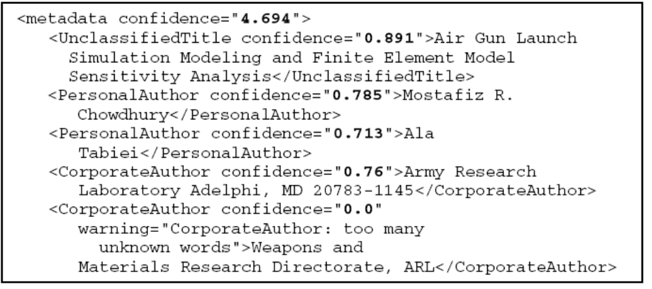
Fig. 5. Sample fragment of validator confidence values. In this example, we see that the second
CorporateAuthor gives a low confidence score because of the existence of too many words not
in the CorporateAuthor dictionary.

Table 1. Sample validator confidence values for a single file


Output Processing. Referring back to the architecture diagram in Figure 1, the extracted metadata from both form and non-form processes enter output processing for postprocessing cleanup and validation.
Post-processing. The post-processing step is designed to compensate for the inherent uncertainties involved in the OCR recognition and extraction process. We have designed a modularized post-processing system which can provide a variety of postprocessing functions for each metadata field. For example, modules may be designed to parse multiple authors from a single personal or corporate author entry and to reformat date fields into a specific standard.
As an example of a post-processing module, we have one module that attempts to standardize acceptable field values in form processing and to overcome the potential for misrecognition by the OCR software. The module analyzes specific fields by comparing the extracted data to values in an authority file.
The module compares these values via fuzzy string matching based on edit distance. Additionally, the post processor can match variable phases where the comparison is successful so long as every word in the authority file entry is contained in the extracted data. We generated the authority file by extracting field data from more than 9000 documents.
Validation. The final step in our process is the validation step. The primary purpose of this step is to determine whether or not to flag the extracted metadata for human review. We will be using the same validation engine as mentioned above in post hoc classification. This validation engine uses statistical models of previously extracted metadata in the collection along with dictionaries for names and specialized content to determine the norms for the collection. While the validator will use the same validation engine to assess individual field values, we do not anticipate using the same script used in the non-form post hoc classification system. At this point we have not yet integrated the final validation module into the implementation. We are currently experimenting to determine an appropriate script to use.

Experimental Results
For our experiments we downloaded 9825 documents from the DTIC collection and 728 from the NASA collection. The internal distribution between forms and non-form documents for the collections are 94% RDP forms for DTIC and 21% RDP for NASA. We conducted a series of experiments to evaluate the effectiveness of the extraction process.

Form Extraction Experiments
The large number of form documents involved prohibits inspecting every document during testing. As such, we randomly sampled 100 form documents from the DTIC collection distributed roughly along the same distribution of the collection.

Table 2. Results for DTIC Form Extraction
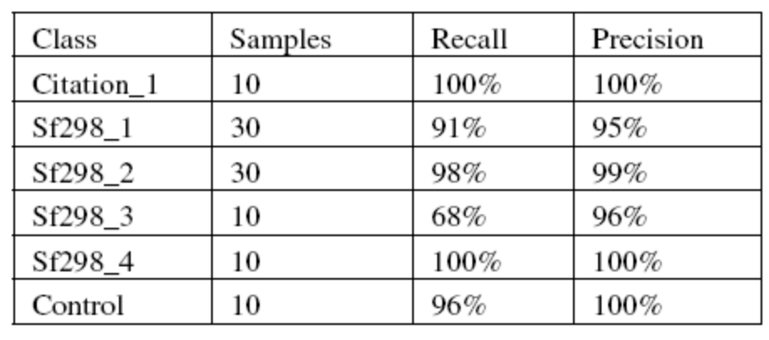

We examined each of the 100 documents and determined the accuracy of the extracted metadata. The results of this experiment are shown in Table 2. Note that the low recall found under the SF298_3 class was due to poor quality of the source documents and resulting OCR recognition.

Non-form Extraction Experiments
We conducted experiments to confirm the efficiency of the post hoc classification system and the ability to extract the metadata. To test the ability of the system to select the appropriate template for extraction, we manually classified the DTIC nonfarm documents into 37 separate classes with at least 5 members. We wrote templates for the 11 largest classes and tested the ability of the extractor to correctly identify the proper class. We achieved an 87% classification accuracy when compared to manual classification results.
The overall accuracy for the non-form extractor was 66% for DTIC and 64% for NASA. The lower value is mostly due to the fact that we have only written a limited number of templates. Assuming that we write all the necessary templates, we expect accuracy in the 90% range.

Automating e-Learning: The Higher Education Revolution

Introduction
As educational institutions throughout the world increasingly offer courses via the Internet, a global lifelong learning economy is emerging in which institutions must compete for students worldwide. This competition is especially noticeable in the offering of postgraduate courses aimed at satisfying the continuing professional development needs of practitioners in a wide range of disciplines. Fifth generation distance education (The Intelligent Flexible Learning Model), incorporating the use of automated response systems and reusable learning objects’databases, has the potential to provide students with a valuable pedagogical experience at significantly lower cost than traditional approaches to distance education and conventional face-to-face education. Such e-learning initiatives will be irresistible to students, politicians and the business community alike – the higher education revolution is inexorable.
Stimulated by the Internet, powerful social, economic and technological forces are revolutionizing traditional concepts of economics, business, and education. Duderstadt [Du01] outlined a number of significant forces driving change in higher education, including the globalization of culture and commerce, the lifelong educational needs of citizens in a knowledge-driven global economy, the exponential growth of new knowledge and new disciplines, and the impact of information and communication technologies. Further, as Quinn [Qu01] pointed out, over 90% of the relevant literature in many technical disciplines, including biotechnology, software engineering and environmental sciences, has been produced since 1985. He also made the point that given the rapidity of worldwide knowledge and technological advance, people cannot (and do not) go back to university for knowledge updates as they once did. Increasingly, neither universities nor individual students can afford the costs (or the time) entailed in taking and presenting traditional classroom instruction.
In the context of such a period of significant change, the Internet will provide the only viable conduit through which corporations and educational institutions, in both developed and developing countries, will be able to provide access to ongoing opportunities for the continuing professional development of working individuals in a cost-effective manner. The demand for postgraduate, continuing professional development of working adults will far outstrip the higher education needs of school leavers typically associated with the demand for university education at the undergraduate level. Traditional programmatic approaches to higher education may even become obsolete, since it could well be beyond the capacity of universities and colleges to adapt to the rapidly emerging market-driven restructuring of the higher education sector. In the face of such unprecedented societal change, will universities become extinct? While many believe that universities will survive the digital revolution, few deny that universities will experience dramatic change in form and structure as a result of the power of technology-driven change.

5th Generation Distance Education: The Emerging e-University
The fifth generation model will not be presented solely as a set of abstract principles, but will be illustrated within the context of the e-University Project, which has been planned thoroughly and is now being implemented gradually at the University of Southern Queensland (USQ). It is worth noting that USQ was the joint winner of the Good Universities Guides’ Australian University of the Year 2000-2001 for criteria focused on developing the e-university.
The Award, presented by the Prime Minister at Parliament House in Canberra, focussed on the preparation of graduates of both undergraduate and postgraduate courses and the university as a whole for the emerging ‘e-world’: http://www.usq.edu.au/GUG2000.htm The e-University Project was conceptualized in terms of three fundamental foci: the e-Information repositories, a variety of e-Applications and the e-Interface respectively. A graphic overview of USQ’s e-University Project is presented in Figure 1.

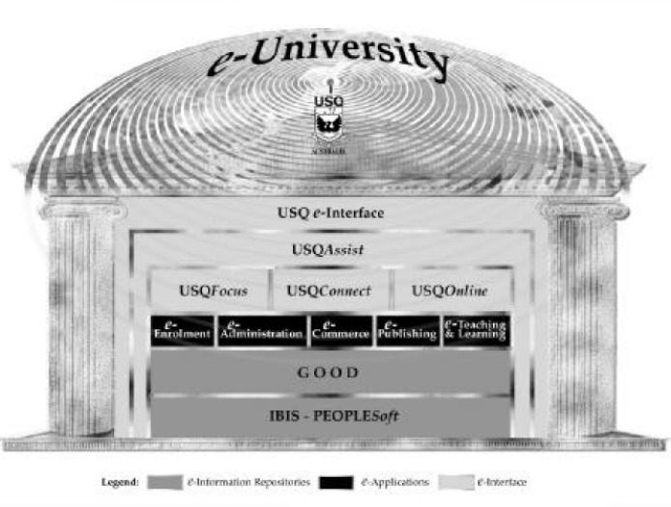
Fig. 1: Overview of USQ’s e-University Project.

Learner Relationship Management
The USQAssist initiative is deploying tracking and automation tools to manage the interaction between the University and both its existing and prospective students. As USQ already has a need to provide global learning services to students enrolled in more than 60 countries, the University has to face the challenge of being responsive to client needs 24 hours per day, 7 days per week. The most efficient, cost–effective way to manage the 24 x 7 challenge is to deploy effective automation tools, as opposed to running three shift student service desks or employing online tutors in different continents (although USQ already does the latter). The aim of such a system is to provide effective and efficient service to existing and prospective students at minimal variable cost.
When the project was initiated in late 1999, there were 13 toll free telephone numbers and numerous help desk facilities offered by various sections of the University. Each of these services provided a valuable service and collected some useful information, but there was no systematic recording and processing of enquiries that would enable USQ to be more responsive to satisfying student needs. The deployment of e-Customer Relationship Management (e-CRM) software (referred to by Milliron and Miles [MM00] as “Learner Relationship Management” (p.60) also known as e-care or e-service) will ultimately enable the use of a single toll free number integrated with an email–based enquiry tracking system that will exploit the fundamental strengths of the Internet in enhancing communication and managing information. Using structured, intelligent databases, the knowledge generated by solving student problems/enquiries is being progressively stored and made available so that, wherever possible, students with equivalent or similar problems can have their enquiries dealt with immediately through the self-help, automated response capacity of the USQAssist system, thereby facilitating effective first point of contact resolution (Fig 2).

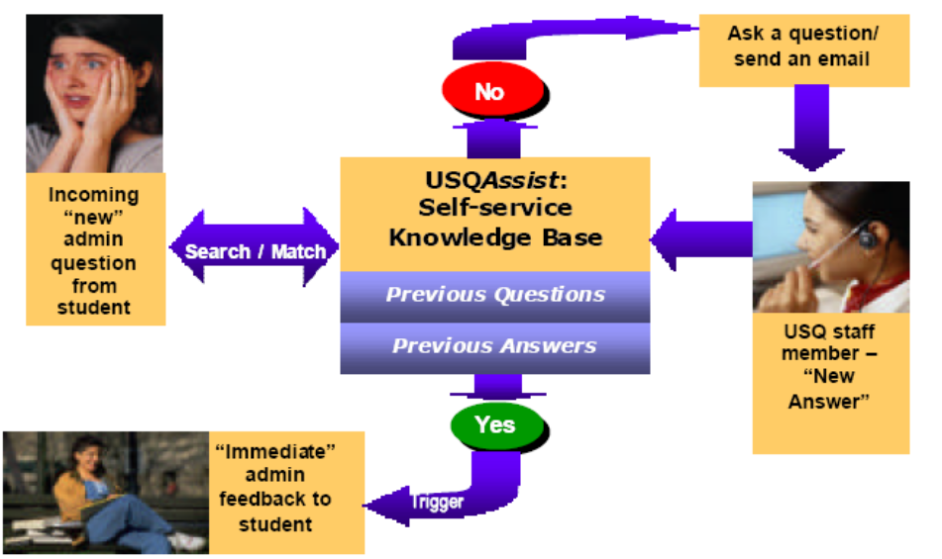
Fig. 2: Schematic Representation of USQAssist

As the dynamic knowledge databases become more comprehensive, enabling personalized, immediate responsiveness to an increasing number of student queries, the institutional variable costs for the provision of effective student support will tend towards zero. The effective use of such technology not only improves the responsiveness of the institution, but also frees up student support personnel to provide personal assistance via email dialogue or telephone as necessary. Further, every interaction is tracked from initiation to resolution, including flexible routing of enquiries based on explicit rules-based escalation protocols to ensure timely and successful responsiveness, and subsequent statistical reporting of system performance. Tracking interactions with prospective students enables the collation of the effectiveness of institutional marketing strategies, an increasingly important strategic issue for universities in the emerging global learning economy, which demands a highly effective public e–Interface with the University.
An associated learner relationship management feature of the fifth generation model is the development of a customizable e-Interface, a campus portal through which students, staff and other stakeholders can engage with the university in a highly interactive and compelling manner. In Norris’ [No00] terms, a well designed campus portal will engender “pervasive, perpetual interactivity “(p.6), which will enable universities to provide such efficient service to students that it is likely to build effective, enduring relationships that could last a lifetime. To be successful in the emerging global lifelong learning market, a university needs to create a campus portal that will achieve a degree of interactivity, user friendliness and personalization that does not exist in the vast majority of campus web sites today. The USQ e-interface is being developed through the application of a web services approach [Do02]. The implementation of the approach has entailed the creation of an Internet Systems Design, Development and Integration Team, and an Online Systems Technical Management Committee (OSTMC).
The OSTMC also provides a useful forum to support the implementation of USQ’s on campus wireless networking initiative http://www.usq.edu.au/its/wireless This part of the strategic plan emerged from concerns expressed by on campus students that they were becoming increasingly disadvantaged by lack of sufficient access to online resources and services, since the computing laboratories were devoted primarily to the teaching of specialized software applications, often requiring access to “high powered” hardware and software. USQ is now in the second phase of the project, wherein funding has been allocated to enable the installation of wireless hubs that will ensure access to the Internet from about 90% of on-campus locations.
The initial successful wireless hub trial conducted in 2000 provided wireless access to the Internet from the Library, the Refectory and the Distance Education Centre. Students gained access to the Internet through laptop computers fitted with a wireless card, providing access at 11Mb using IEEE 802.11b wireless standards. This freedom to have access to the Internet from virtually anywhere on campus is a key feature of providing access to online courseware and services to all students whether on or off campus. The key to the success of such initiatives is, of course, detailed execution and associated, institution-wide organizational development strategies with the aim of ultimately enabling the automation of online teaching and learning support systems.

Automating e-Learning
How does it work? In the USQ approach, many teaching staff make use of discussion groups, which entail students posting “reflections” via the asynchronous computer mediated communication (CMC) system. The teaching staff also post comments, which are aimed at engendering student engagement and ensuring that the focus and depth of the online threaded discussions are appropriate to achieve the learning outcomes. In the same vein, members of the teaching staff respond to student questions posted to the discussion group. These contributions are often quite complex and typically serve to enhance the quality of interaction. Development of a detailed response to a searching student query naturally takes time. A positive feature of the system is that the communication is on a “one-to-many” basis, so that all students may benefit, not just the one who asked the initial question.
Further, our experience demonstrates that other students often comment on the issues raised thereby enriching the depth and quality of the dialogue. The value of these contributions is particularly useful where students are giving examples of applications in different cultural contexts. Such interactions may take place in conventional classroom settings, but the difference is that they are ephemeral and not documented for detailed reflection as they are in the CMC system.
At present, the effective use of CMC is presently constrained in an important way. It is still a function of what Daniel [Da99] recently referred to as the “cottage-industry model”, which entails the traditional working practices of universities, wherein the same academic staff member usually does everything, including teaching, providing academic support and assessment for a group of students. In effect, the current applications of fourth generation Internet-based delivery tend to generate res ource allocation models similar to tutorial-based on campus teaching. Indeed, it is still a fear of many academics initiating an online teaching program that they will be overwhelmed by email requesting support from individual students.
While such fears can be allayed by the use of “one-tomany” communication systems such as bulletin boards, mailing lists and threaded discussions, the underlying resource model is not significantly different from conventional on campus teaching, with a staff member being necessary to manage groups of approximately 20 students to maintain a reasonable quality of interaction and academic support. In contrast, the fifth generation Intelligent Flexible Learning Model has the potential to deliver major economies of scale in managing teaching and academic support through the exploitation of automated response systems (Fig 3).

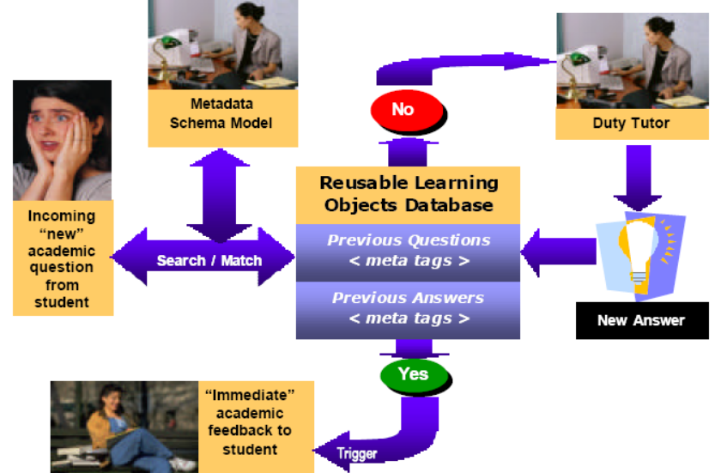
Fig. 3: Schematic representation of USQ’s 5th Generation Academic Productivity Enhancement System

Our work at USQ has reached the point, where we have tested the 5th Generation Academic Productivity Enhancement prototype. Upon receipt of an electronic query from a student, the staff member references the incoming question to a metadata schema model which has been devised for the course in question; the search engine then seeks an appropriate match with a previously asked question, which if successful, triggers a potential range of answers to the current question without further human intervention. At this stage of development, the design of the system entails a tutor checking the validity of the match between the current question and the answers generated from the database before forwarding to the students with a single click of the mouse. Such a quality control mechanism may become redundant in the future. If no appropriate match is discovered in the database of previously answered questions, the query is automatically routed to the relevant tutor for an appropriate response, which is then added to the database with a single point and click.
Depending on the pedagogical design of the course, these responses can be directed to the whole cohort of students, to groups of students, or to individuals. The system has the advantage of providing more -or-less immediate pedagogical advice to students, a significant increase in institutional responsiveness, at minimal variable cost. It is worth noting that this system is not just aimed at reducing costs, USQ has a research program producing empirical evidence aimed at to validating the potential pedagogical efficacy of the approach, as illustrated by the following brief discussion of underlying instructional design theory and an associated exemplary investigation.

Your solution

Introduction
// introduction for this section

Overview figure, architecture with description (inputs, processing, outputs)
Describe in terms of the comparison criteria

Detailed description
xxx

subheading
xxx

subheading
xxx

Tool Support

subheading

Validation results
xxx

subheading
xxx

subheading
xxx

Conclusions
// conclusions for this section

Conclusions and Future Work

subheading
xxx

subheading
xxx

subheading
xxx

subheading
xxx

subheading
xxx

subheading
xxx

References
// use correct format for book, journal, conference paper
// avoid websites

- C. Shaun Longstreet, Kendra Cooper, A Meta-model for Developing Simulation Games in Higher Education and Professional Development Training, IEEE 17th International Conference on Computer Games, Kentucky, USA ,2012
- S. Tang, M. Hanneghan, A Model-Driven Framework to Support Development of Serious Games for Game-based Learning, School of Computing and Mathematical Sciences, Liverpool John Moores University, UNITED KINGDOM, 2010 Developments in E-systems Engineering, IEEE Computer Society, 2010 .
- Cheng-ping Chen, Ju-ling Shih, A Prototype on a Meta-model for Designing Instructional Pervasive Games, Department of Information and Learning Technology, National University of Tainan, 2012 Fourth IEEE International Conference On Digital Game And Intelligent Toy Enhanced Learning, 2012.
- Sara de Freitas, Learning in Immersive Worlds: A review of game-based learning, Prepared for the JISC e-Learning Programme.
- Jeannette Bennett, Kendra Cooper, Lirong Dai, Aspect-oriented model-driven skeleton code generation: A graph-based transformation approach, Science of Computer Programming 75, pp: 689_725, 2010.
- Antti Kirjavainen, Development of Game-Based Learning Environments – Constructing a Quality Multi-Disciplinary Development Process, University of Jyvaskyla, Department of Mathematical Information Technology & Agora Center, Dissertation in Information Technology, October 6, 2009.
- Masoud Hemmasi, Lee A. Graf, Illinois State University, EDUCATIONAL EFFECTIVENESS OF BUSINESS SIMULATION GAMING:A COMPARATIVE STUDY OF STUDENT AND PRACTITIONER PERSPECTIVES, Development In Business Simulation & Experiential Exercises, Volume 18, 1991.
- S. Tang, M. Hanneghan, Fusing Games Technology and Pedagogy for Games-Based Learning Through a Model Driven Approach, School of Computing and Mathematical Sciences, Liverpool John Moores University, Liverpool, UNITED KINGDOM, 2011 IEEE Colloquium on Humanities, Science and Engineering Research (CHUSER 2011), Dec 5-6, Penang, 2011.
- Nathan Balasubramanian,Brent G. Wilson, GAMES AND SIMULATIONS, Society for Information Technology and Teacher Education (SITE), 2005.
- Tsung-Li Wang, Ya Fen Tseng, Learning Effect for Students with Game-based Learning on Meta-Analysis, The 6th International Conference on Computer Science & Education (ICCSE 2011), pp. 1291-1295, August 3-5, 2011. SuperStar Virgo, Singapore, 2011.
- Javier Torrente, Pablo Moreno-Ger, Baltasar Fernández-Manjón (2008). Learning Models for the Integration of Adaptive Educational Games in Virtual Learning Environments. Proceedings of the 3rd International Conference on E-learning and Games (Edutainment 2008), Nanjing, China. Lecture Notes in Computer Science 5093, pp. 463–474.
- Miroslav Minović, Miloš Milovanović, Mladjan Jovanović, Dušan Starčević, Model Driven Development of User Interfaces for Educational Game, HSI 2009 Catania, Italy, May 21-23, 2009
- Lina Marcela Morales, David Mendez-Acuna, Willy Montes, Model Driven Game Development - Case Study A MTC for maze game prototyping Departamento de Ingeniera de Sistemas y Computacion, Universidad de los Andes, Colombia.
- Marcio de O. Barros, Alexandre R. Dantas, Gustavo O. Veronese, Claudia M. L.Werner, Model-driven Game Development: Experience and Model Enhancements in Software Project Management Education, Softw. Process Improve. Pract. pp. 411–421. 2006.
- Miroslav Minovic, Milos Milovanovic, Dusan Starcevic, Modelling Knowledge and Game Based Learning: Model Driven Approach, Journal of Universal Computer Science, vol. 17, no. 9 pp. 1241-1260. 2011.
- Diana Oblinger, Simulations, Games, and Learning, EDUCAUSE, May 2006.
- STEPHEN TANG, Martin Hanneghan, State of the Art Model Driven Game Development: A Survey of Technological Solutions for Game-Based Learning, Journal of Interactive Learning Research (201 1) 22(4), pp: 551 -606.
- Josephine M. Randel, Barbara A. Morris, C. Douglas Wetzel and Betty V.Whitehill, The Effectiveness of Games for Educational Purposes: A Review of Recent Research, Simulation & Gaming, 1991.
- Kendra Cooper, C. Shaun Longstreet, Towards Model-driven Game Engineering for Serious Educational Games: Tailored Use Cases for Game Requirements, IEEE 17th International Conference on Computer Games, Kentucky, USA ,2012.

Appendix A. title here

